What Does a Server Do?

When you connect to the Internet, you are connecting to a global information network linking your device to the content you request. Your device, called a *client device*, is the computer, tablet, or smartphone used to connect to the Internet.

What happens when your client device accesses information from the Internet?

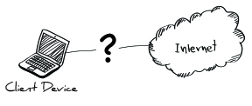

There are many steps along the way. In a typical scenario, your PC, laptop, or smartphone connects to Router via WiFi or an Ethernet connection. This WiFi router connects to a router linking you to an Internet Service Provider (ISP).

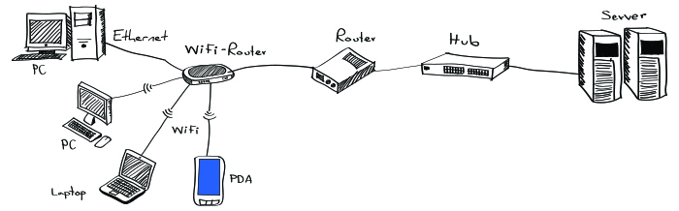

Content requests from your client devices travel through your router to the ISP, where they are directed across a series of routers, hubs, and switches until they reach the correct server. The requested content is then sent back from the server along the same path to your client device.

The path between a client device and server can cross the globe. However, only 40% of the world has access to an Internet connection.

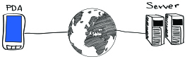

This is where Smile comes in. Smile’s Micro-Cloud Server acts as a server and a WiFi-Router in one unit.

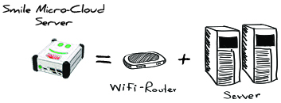

Client devices can connect via WiFi or Ethernet directly to the Smile Micro-Cloud, and access the content and applications that are served from the Micro-Cloud without the need for an Internet connection.

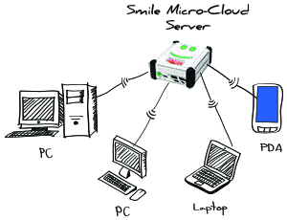

If an Internet connection is periodically available, then Smile can sync and update the content and applications that it serves. Smile Micro-Cloud provides an ad-hoc infrastructure that can serve information to the rest of the world.